BJ60S
BiJie Meeting Box Specifications

Appearance
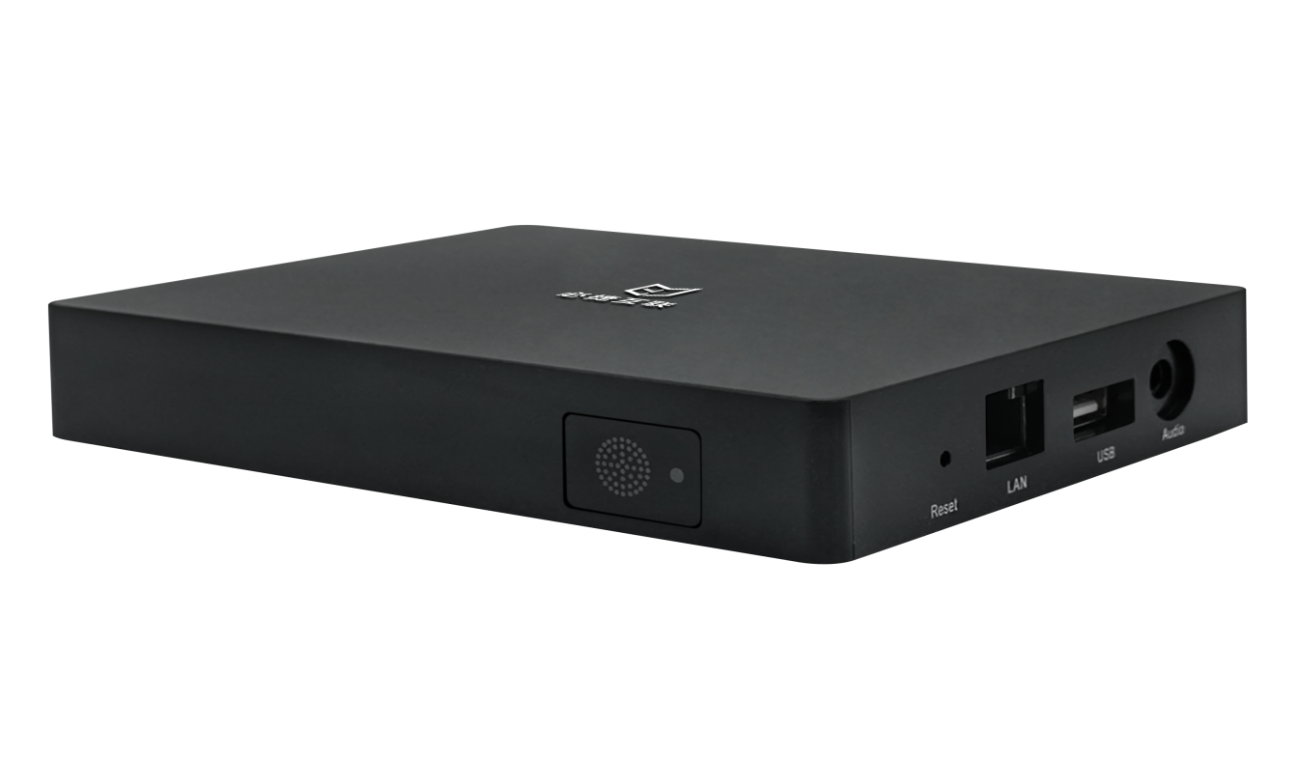

Features
- Support QR mirror and Short Code mirror
- Support 2 display of wireless projection
- Support wireless projection from Android、iOS、Mac、Windows
- Support AirPlay/Miracast/WiDi/BJCast
- 2.4G+5G dual-frequency wifi mode
- 4K HD display
- Provide AP hotspot
- Provide wireless projection SDK
- Support unified platform of management

Specification
items |  | Specifications
 | Operate system | Android
 | WiFi module | 802.11AC*2 module
 | WiFi AP | AP hot
 | Network | Support wired, wireless, 802.1x
 | LED light | White LED
 | USB interface | 1 * USB3.0 1*USB2.0
 | Video output | HDMI *1
 | Audio output | 3.5mm audio port
 | WIFI antenna | Built in high performance wifi antenna
 | Boot time | ＜30s
 | Power | DC5V2A
 | Size | 127*97*20mm
Wireless Projection  Functions | Airplay | Support Apple’s iOS、MacOS devices’ Airplay、no need to install any app  Support airplay multi-display(Present multiple screens at the same time)
 | Miracast | Support Android devices（phone、Pad）、no need to install any app  support Miracast multi-display(Present multiple screens at the same time)
 | WiDi | Support Windows8/10、no need to install any app  Support WiDi multi-display(Present multiple screens at the same time)
 | BJCast | Support windows, MAC, Android, IOS device installation software client mode for wireless projection  Provide Android, IOS, MacOS, windows 4 sets of transmitter software
 | USB transmitter | Support Windows / Mac computer plug-in USB transmitter screen projection, provide visitors screen projection solution
 | Number of multi-display | 2
 | Reverse Control | Support BJCast、USB transmitter、Miracast、WiDi
 | QR for projection | Support scanning QR code
 | Short code for projection | Support direct input of screen projection code
 | Delay of projection | ≤200ms
 | Distance of projection | 30m
 | PIN of projection | Support screen casting security encryption, compatible with miracast pin code function
 | Wallpaper | Custom replacement and wallpaper automatic update plan
 | Customize device name | support
 | language | Simplified Chinese, traditional Chinese, English,
 | Unified management platform | Support
 | SDK | Provide wireless screen projection SDK and support third-party integrated development
Warranty |  | One year

